**HTML Homework**

**Basic Task:**

Create a single HTML site including the following elements. Special attention needs to be paid to the file structure, indenation, structure and comments

**Page 1**

<header>...</header>

<nav>...</nav>

<ul>...</ul> and / or <ol>...</ol>

<a>

<main>...</main>

<h1>...</h1> to <h6>...</h6>

<footer>...</footer>

<div>...</div>

<img />

<p>...</p>

**Extended Task:**

Create the second page so it contains the following elements, and link the two pages together

<video>...</video> or <iframe>

<table>...</table>

**Project organisation**

A tidy project is essential for coding, and everything should be in its place. Feel free to add a new folder so long as the files within are relevant

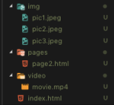

**The theme is up to you, but it could look something like:**

index.html

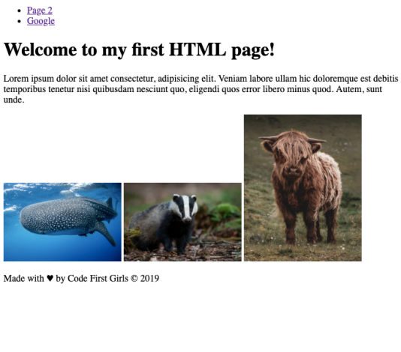./pages/page2.html

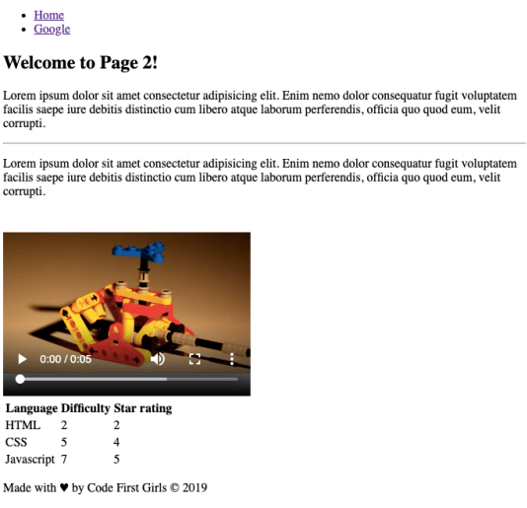**Tips and resources**

keep an well-organised project - it will help you heaps!

Video Download

Traversy media HTML

w3schools

And most importantly, have fun!